Bean Bag Frog
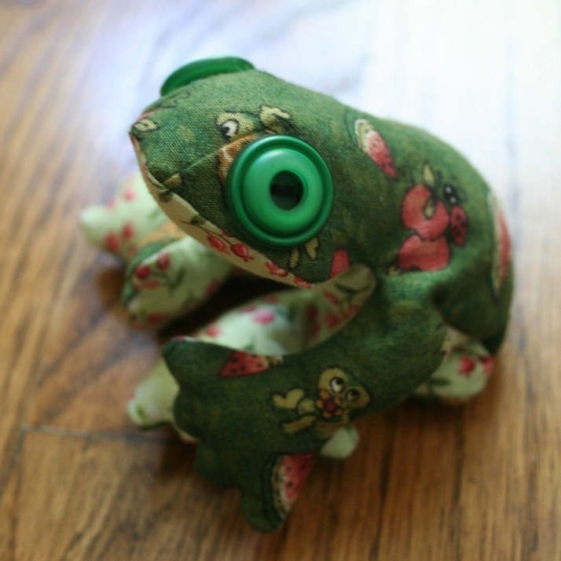

Materials:
Small Frog: | Large Frog | Both
2 pieces of cotton or fleece fabric 24 cm x 23cm | 2 pieces of cotton or fleece fabric 27 cm x 25cm | Sewing thread to match the fabric
2 Googly eyes or buttons | 2 Googly eyes or buttons | Sewing machine
(optional) | (optional) | Hand needle
 |  | Filling & Funnel
 |  | Scissors
 |  | Sewing machine

Instructions:
- Choose a pattern size and two flannel fabric pieces – they do not have to be the same colour or pattern. Be sure you choose the right size of fabric for the pattern size. You may choose to sew the large or small size frog.

- Pin the two pieces of fabric together with the right sides facing each other. The right side will be the side that looks brighter.

- Pin the fabric pieces together around the edge of the fabric and place the pattern in the middle of the fabric. Use a Sharpie to trace around the pattern; cut out both pieces of at the same time to ensure both sides are the same shape and size (fig.1).

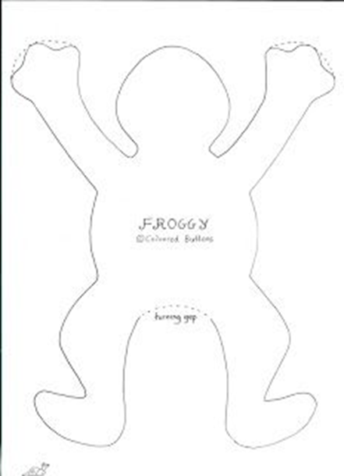
Figure1:

- Draw a dotted line about 0.5 cm from the outline of the frog. This is your cutting line when you finish sewing the frog.

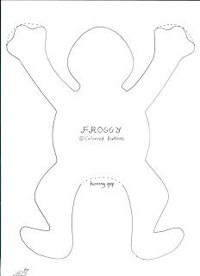
Figure 2:

- Sew along the outline you drew, pivoting at the places where you are going to change direction. You will also need to pivot around the top of the ears, around the tail, and the feet. Ensure the needle is in the down position and the presser foot in the up position before moving your fabric. See figure 2.

- Continue to sew around the frog leaving a 5cm opening along the back for turning. Cut out along the cutting line you drew.

- Once you have stitched around the frog, clip the fabric along the curves – space them about 0.5 cm apart. DO NOT CUT THROUGH THE STICHES. See figure 3.

Figure 3:

- Press your frog. Turn it outside right, using a pencil or pen to ensure the toes are also turned out.

- Use a funnel to fill the frog with oats.

- Turn the fabric along the opening to the inside and use a ladder or slip stitch to close. See figures 4 and 5.
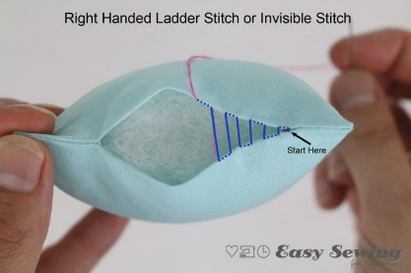
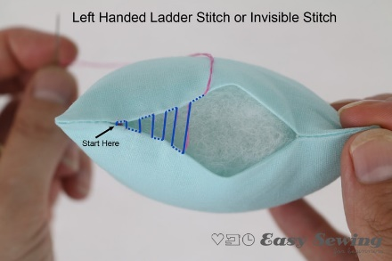
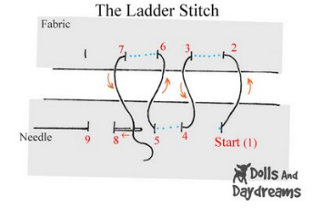
Figure 4: Figure 5:

- Optional: before the frog is stuffed, sew one googly eyes or buttons

