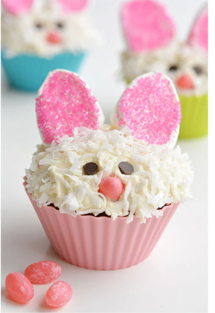
Easter Lemon Cupcakes with Lemon Curd
Cooking Principle: Shortened Cake Method
Time: 18-22 min
Temp: 350ºF
Yield: 6 cupcakes

Ingredients:
Cake | Icing & Decorations
.100g (190 ml) flour | 75g (80 ml) margarine
100g (125 ml) sugar | 130g (250 ml) icing sugar
54g (60 ml) margarine | 5 ml milk
1 ml salt | 2 ml vanilla
60 ml milk | 30 ml lemon pie filling
1 egg | 6 large marshmallows
40 ml lemon juice | 10 ml coloured sugar
5 ml lemon zest | 6 jelly beans
3 ml vanilla | 12 chocolate chips
5 ml baking powder | 125 ml coconut - optional

Method:

- Preheat oven and line muffin tin with cupcake liners.
- Place the margarine and sugar in a large mixing bowl. Cream together with a wooden spoon or an electric mixer.
- Add the egg and vanilla and beat to mix.
- In a medium mixing bowl whisk together dry ingredients. Mix in the lemon zest. Make the milk and set aside.
- Add 1/3 of the dry ingredients to the creamed mixture in the large mixing bowl. Beat at low speed until incorporated.
- Add ½ the milk and all the lemon juice and beat until combined. Add another 1/3 of the dry ingredients, beat to incorporate; add the rest of the milk, mix; then add the remaining 1/3 of the dry ingredients. Beat to fully incorporate and the batter is smooth.
- Divide the batter evenly between the 6 muffin cups filling ½ -2/3 full.
- Bake 18-22 minutes or until a toothpick comes out clean. Remove from the pan and place in a single layer on a plate.
- Cover the cupcakes with plastic wrap, label and place on the upper shelf in the cupboard for Day 2.

Day 2: Icing:
- Combine margarine and icing sugar in a large mixing bowl and beat with electric mixer until smooth and creamy.
- Add milk and vanilla, beat until fluffy. Set aside until ready to decorate your cupcakes.
- The icing should be thick enough for a furrow to remain when you run the flat edge of a metal spatula through. If it is too thin, add more icing sugar.

Filling and Decorating
- Using a paring knife, cut a 2cm diameter cone about 2.5 cm deep out of each cupcake and set aside.
- Fill each hole with ~5 ml lemon pie filling. Cut the point off each cone you cut out and place the remaining flat disc over the to top of the hole to cover.
- Spread the icing in an even layer over the top of each cupcake being sure to cover the disc over the filling. Divide the icing between the 6 cupcakes – be sure you have a thick enough layer for the decorations to stick in the icing layer.
- Optional: place coconut in a cereal bowl. After icing each cupcake, dip and rotate the top of the cupcake in the coconut to evenly cover the entire surface.
- Place the coloured sugar into a custard cup. Cut the marshmallows in half diagonally with a knife. Dip the sticky portion into the coloured sugar and place on the cupcake – you may need to move the coconut out of the way.
- Make the face by placing on the chocolate chips for the eyes and the jellybeans for the nose.

Standards:  Toothpick comes out clean, icing correct consistency, bunny face clearly seen, filling not overflowing | Equipment on Tray:

