B E G I N N E R W E A V I N G T O O L S

HOW TO MAKE A CARDBOARD LOOM
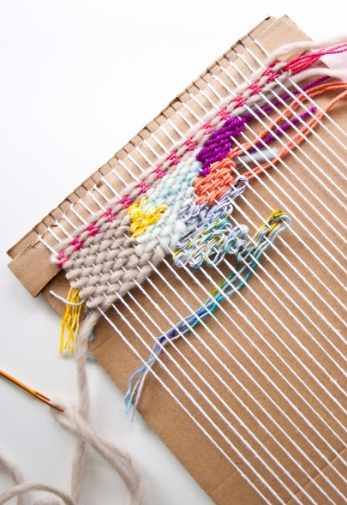
How to Make a Loom out of Cardboard and Start Weaving! For those that want to try weaving, but don’t want to spend money on a loom before they know if they’ll like it, this is your post. And this post can also be used for those that want to make a temporary large loom or just have a second loom. Making a loom out of cardboard is pretty simple! And I’m going to also show you how to make it a step fancier, because we’re friends like that. Here we go…

How to Make a Loom out of Cardboard and Start Weaving
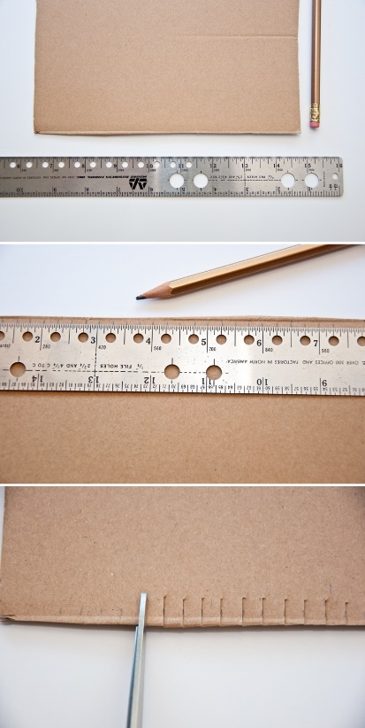
Step 1| get yourself a piece of cardboard, any size that you want. Mine is about 8 inches by 11 inches, but you can pick a piece larger or smaller (which is the best part). Try to find a strong cardboard, but if you don’t have a strong piece, then you can also layer a few pieces by gluing them together.

Step 2| using a ruler, find the middle of your cardboard and then start marking off every ¼ inch (or 6mm works too!) across the top of your piece. I like to leave at least 1 inch free of marks on both sides of the loom for stability.

Step 3| using your ruler again, find the middle of the bottom. Make sure this is exactly across from the middle of the top. Then mark off every ¼ inch (or 6mm). Your top marks and bottom marks should align.

Step 4| next cut each of your marks ¼ inch deep (or 6mm) on both top and bottom of cardboard.

You could stop here with your loom, but like I said let’s add some fanciness!
Step 5| now cut two pieces of cardboard that are 1 inch tall and as wide as your cardboard loom.

Step 6| glue these two pieces to your cardboard loom just under your cut tabs. One will go at the top and one at the bottom. These pieces will help ease tension on your cardboard tabs and also give you some weaving room, because it creates a gap under the warp threads.
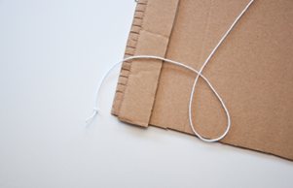
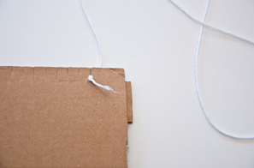
Alright you’ve got yourself a nifty little loom! To warp the loom, I simply tied my warp thread in a knot and put the knot at the back of the first tab on the bottom. If you have the knot at the bottom, then you can use the warp thread loops to hang your weave from (which is definitely helpful!).
Once your knot is secure, then warp across the front of the loom. Bring the warp around the tab in the back of the loom and then back across the front (see the picture). Keep warping until the end and tie your warp thread in a single knot at the back of the loom, making sure to have the knot end on the bottom of the loom also.
hen weave away! If you need help finishing your weave and getting it off the loom, follow these steps here for the yarn tails and bottom warp threads. Then follow these steps for the top warp loops. I also have a bunch of fun weaving techniques listed out here, for you to try!
Are you new to weaving? Feel free to ask me questions and I’ll help as much as I can.
Happy Weaving!
Kate

