How to Measure Ingredients Properly
How to Measure Ingredients | Blue Jean Chef - Meredith Laurence
Measuring properly can make or break a recipe and there is a right way and a wrong way to measure. Don't fall into bad measuring habits. Learn how to measure ingredients properly so you can guarantee success.

WHY IT’S IMPORTANT TO MEASURE PROPERLY

ESSENTIAL MEASURING TOOLS

HOW TO KNOW WHAT TOOLS TO USE

HOW TO MEASURE DRY INGREDIENTS

By Volume:

By Weight:

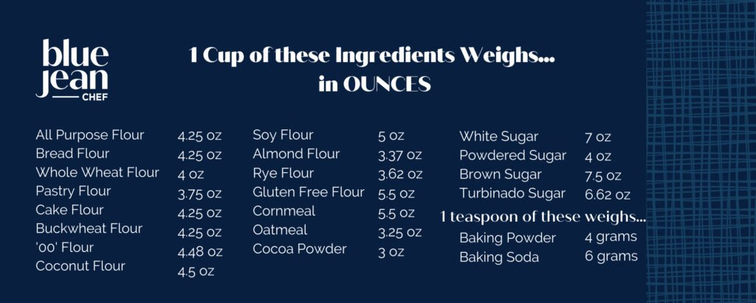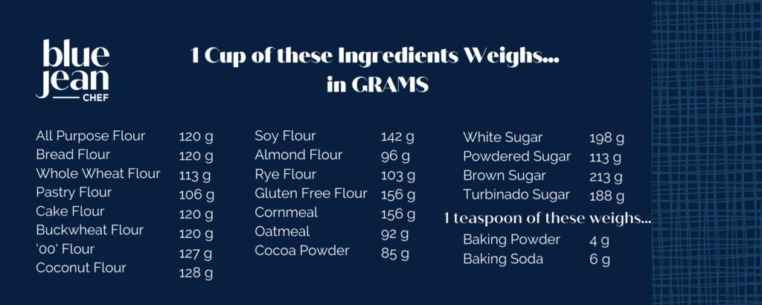

EXCEPTIONS TO THE DRY INGREDIENT RULe

Brown Sugar

Powdered sugar

TABLESPOON AND TEASPOON

HOW TO MEASURE WET INGREDIENTS

TIP FOR MEASURING STICKY INGREDIENTS
Sticky ingredients can be a challenge to measure, whether you’re using a liquid cup measure or a measuring spoon, but there’s a super useful tip to make it easier.

All these rules for how to measure ingredients properly may seem obvious, but they are important to know and do have an impact on how your recipes turn out. Get into the habit of using the right tool for the job and then using that tool correctly. It’s the first step in getting better baking and cooking results.

