I Spy Mug Mat Tutorial
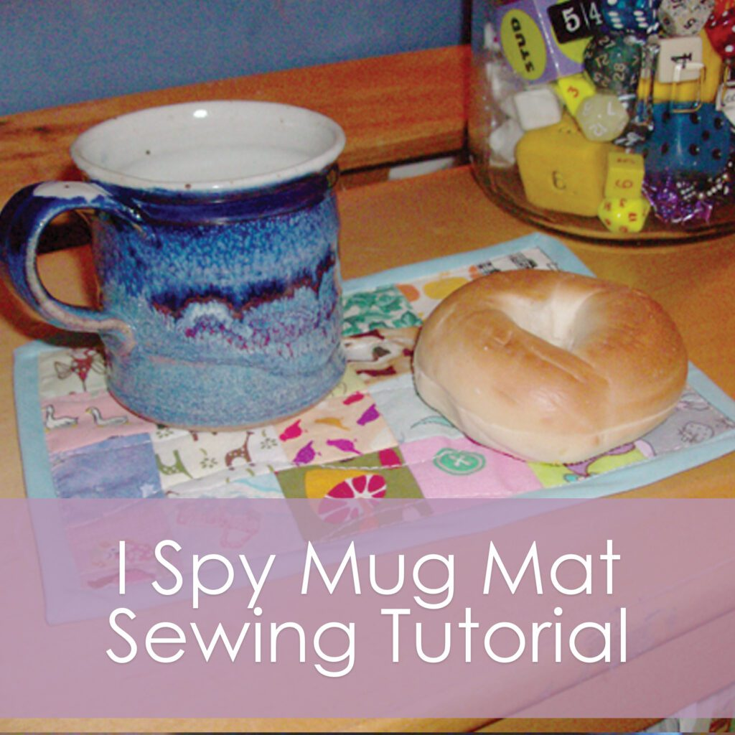
Lately, I have been obsessed with mug rugs, which are also called snack mats. They are adorable and fun. They use up your scraps and make lovely little pieces of art for your table.
I made this I-Spy snack mat to make snack time even more fun… little people can play a game of “I Spy With My Little Eye” while they wait for their snack! I’ve made these mats 6x9inches which I think is a perfect size- you could really use more or fewer squares and go with whatever shape you like!
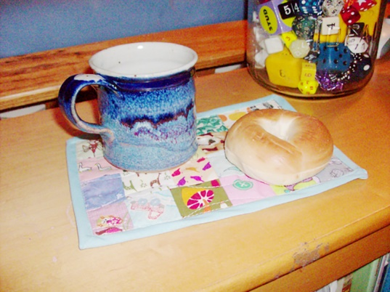
What you need:
24 scraps of fabric at least 2 inches square, each with different interesting and easily recognizable items on them
1 6x9inch piece of fabric for the backing
1 6x9inch piece of cotton batting or flannel
wide bias tape
What to do:
1. Cut your 24 scraps into 2x2inch squares. You want these patterns to be small enough to fit about 1.5×1.5 inches and you might have to fussy cut them to get a recognizable object.
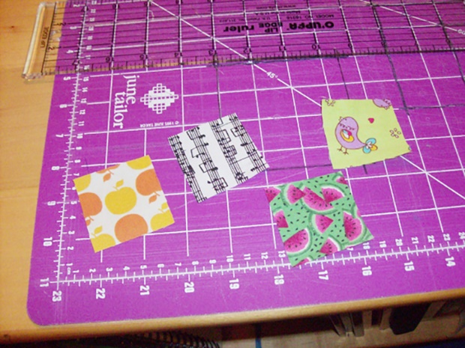
2. Sew all the squares into pairs with a 1/4inch seam allowance. Press the seams open.
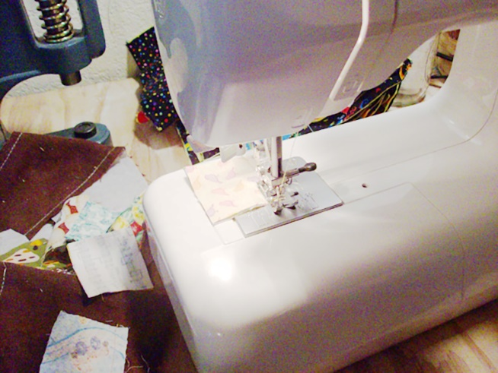
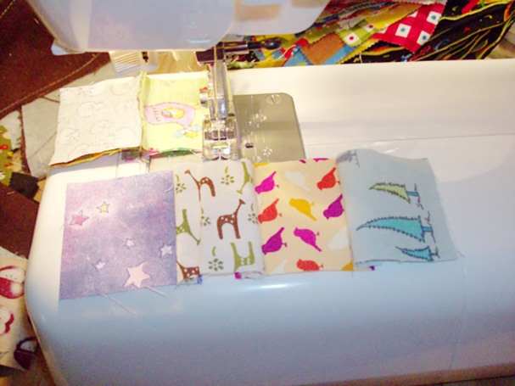
3. Sew the pairs to other pairs until you get 4 strips with 6 squares each.
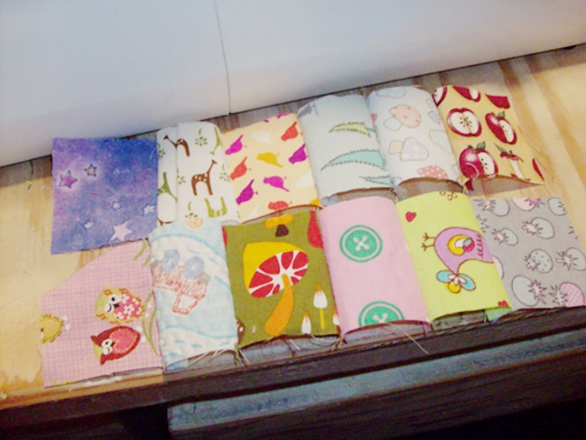
4. Sew your strips together to make a rectangle that is 6 squares across and 4 squares down. Remember to press seams open! This is the mat top.
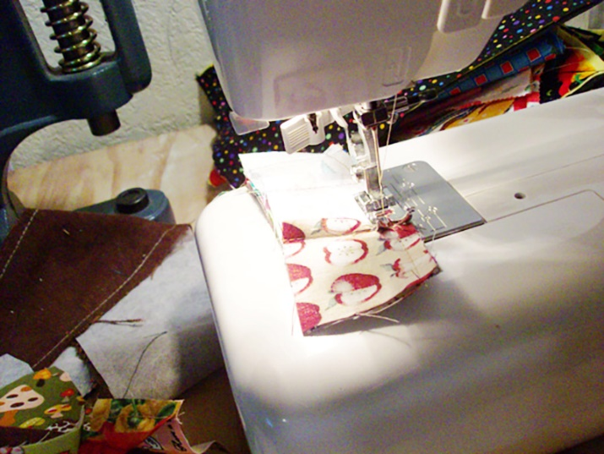
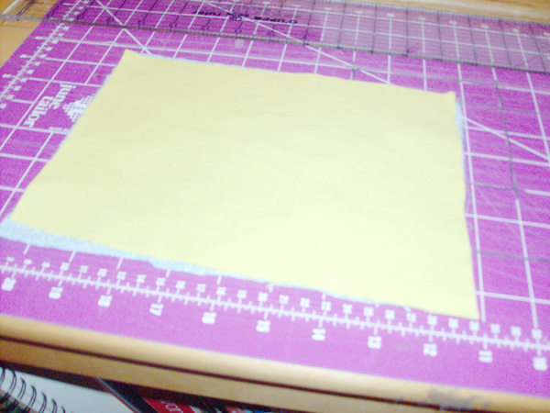
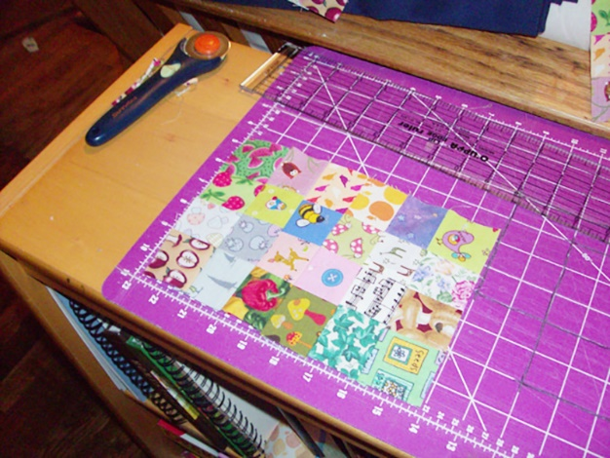
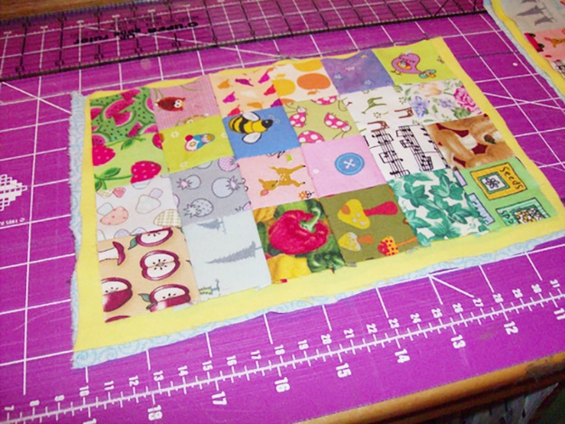
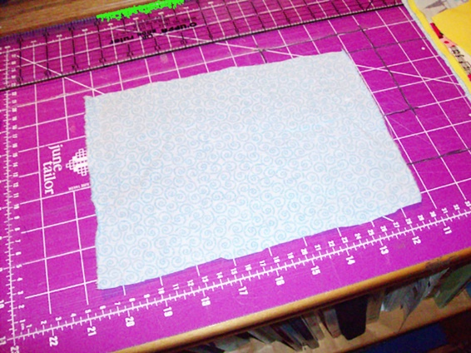

5. Layer the backing, batting and mat top: backing with right side down, batting, mat top with right side up. Pin the layers together.
6. Quilt the mat as desired. I’m not anywhere near a quilting expert- I just kind of sewed lines and I think it turned out pretty darn well.
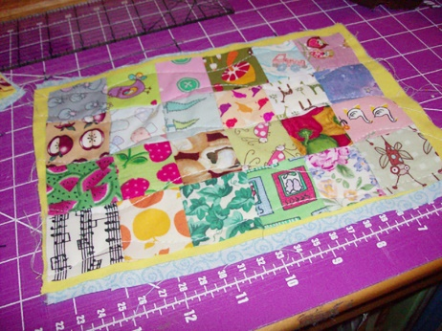
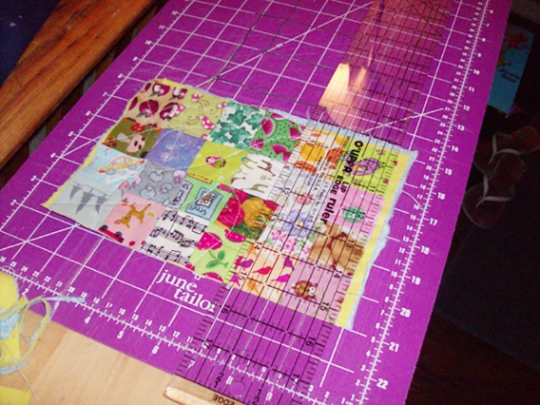
7. With your ruler and rotary cutter, trim all four sides so they are straight.

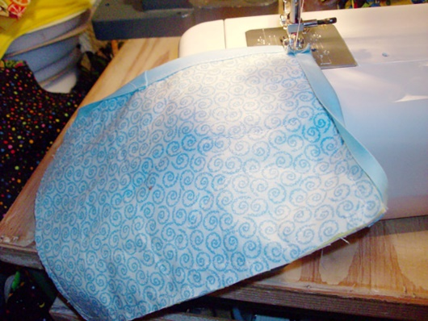
8. Apply the bias tape.
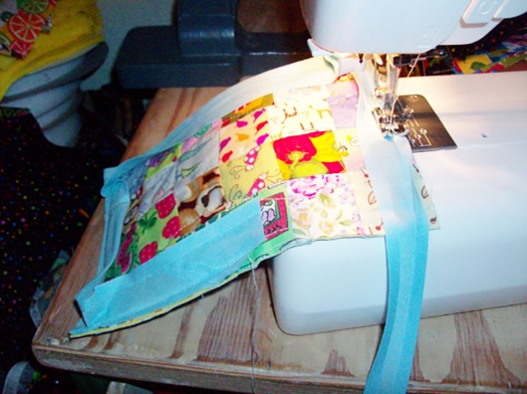

9. Done! Enjoy your snack and see what you can find while you eat!
