Little Birdie

7.5 cm H x 7.5 cm W x 15 cm L

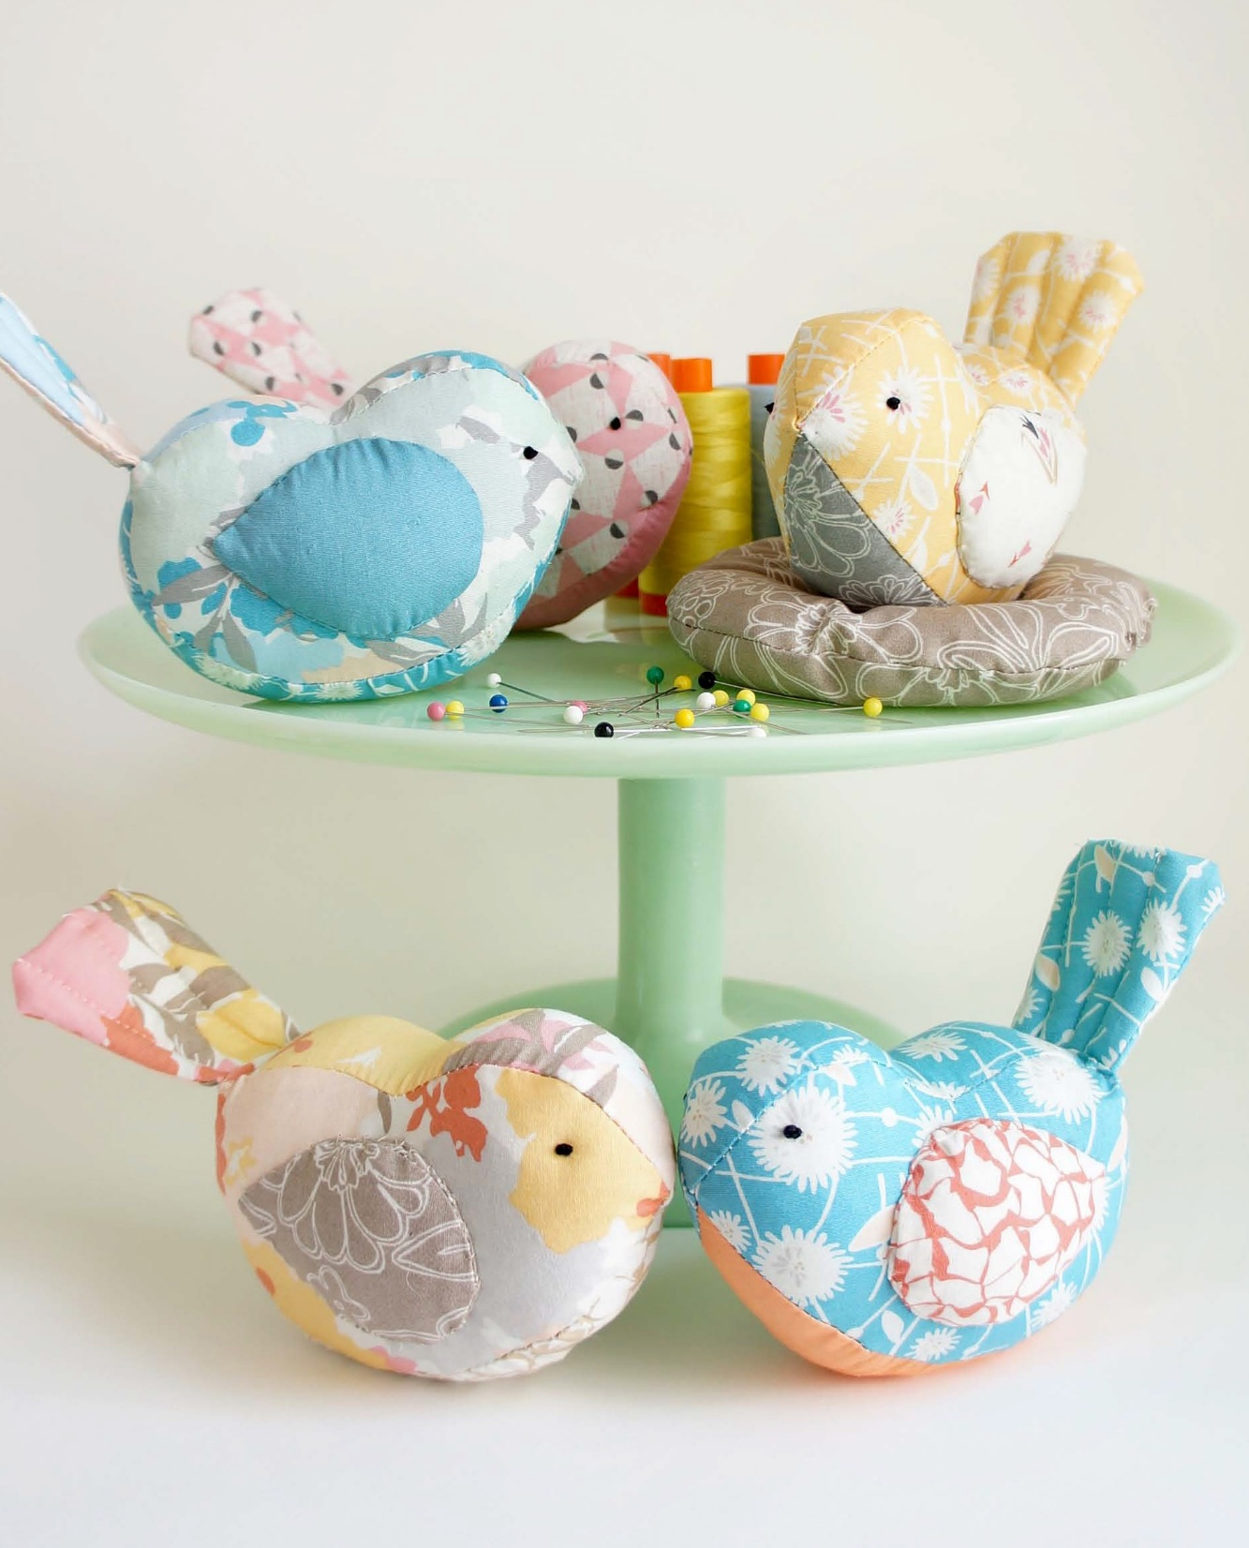
+Sew

FREE Pattern

1”. Trace the shapes onto the template material, transfer dots, then out out the templates neatly and label.

Skill Level: Intermediate
Size: 7.5 cm H x 7.5 cm W x 15 cm L Designer/Maker: Sharon Holland

NECESSITIES

For 1 Bird:
• 22.5 cm x 30 cm print rectangle (for body, back, and tail)

• 20 cm square (for wings and tummy)

• 10 cm square muslin

• Fabric marking pen

• 60 ml dried lentils or craft pellets

• Fiberfill

• Embroidery needle and dark brown floss, small beads, felt circles, or buttons (for eyes)

For 1 Nest: optional
• (2) 20 cm squares brown print

• Chalk pencil
PREP
PREP
Cut all strips from selvage to selvage. Remove the selvages. Check that the templates are printed full size by verifying that the reference square measures exactly

Read through all instructions before beginning. Sew pieces right sides together and use a0.5 cm seam allowance throughout unless otherwise stated.
Trace the templates on the wrong side of the desired fabrics. Follow the directions on the templates to cut shapes and reverse shapes. Cut the shapes out on the drawn lines. Use the fabric marking pen to transfer seam intersection marks onto the wrong side of the fabric and the eye placement dot onto the right side of the fabric.

PINCUSHION
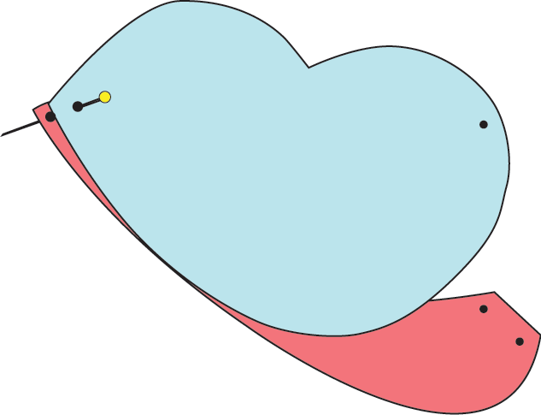
- Pin one body and one side of tummy together at the beak dot and tail dot. Starting at the beak points, use a backstitch 0.5 cm from the edge to sew the tummy to one side of the bird. Stop at the tail point dot. Tie off the thread and cut off. Repeat for the other side with the second body, again starting at the beak. Clip the curves – cut the material along the curved edge making sure you don’t cut the thread along the seam.

- In the same manner as the tummy, pin one body and one side of back together at the beak and tail dots. Starting at the beak points, use a backstitch 0.5 cm from the edge to sew the tummy to one side of the bird. Stop at the tail point dot. Tie off the thread and cut off. Repeat for the other side with the second body, again starting at the beak. Clip the curves – cut the material along the curved edge making sure you don’t cut the thread along the seam. Repeat for the other side, again starting at the beak. Clip the curves. Leave the tail open for turning and stuffing. Turn right side out.

- Fold the 10 cm muslin square in half. Sew along two sides; do not turn right side out. Fill the pouch with dried lentils or craft pellets, leaving enough space to stitch the opening closed. Stuff the pouch inside the tail opening and position it on the tummy so the bird sits flat. Stuff the rest of the bird firmly with fiberfill and set aside.

Leave one short
end open for filling

- Sew the tail right sides together, leaving the short end open. Clip the corners and turn right side out. Stuff lightly with fiberfill. Stitch 3 lines to give the tail definition.

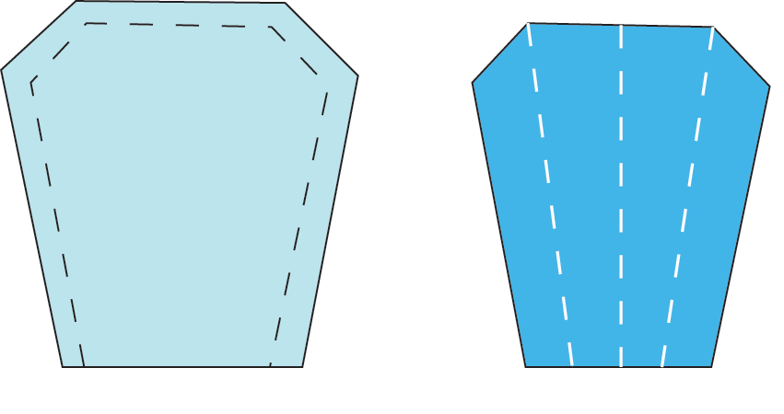
NEST
1. On the wrong side of (1) 20 cm square, draw a 17.5 cm circle with a compass or by tracing around a bowl. Pin squares right sides together and sew on drawn line, leaving a 5 – to 7.5 opening for turning. Trim excess, leaving a 0.5 cm seam allowance around the drawn circle.
Clip curves and turn right side out.

Leave short end open Lightly fill and sew 3 division lines to give tail dimension

5. Place the raw edge of the tail into the tail end opening of the bird, turning the raw edges of the opening under 0.5 cm Hand sew the tail in place and the opening closed with a running stitch.

6. Sew 2 wings right sides together all the way around. Clip the curves. Make 2 wings. Verify that the wings are mirror images on the sides of the body. Cut a small slit in the center of each wing that will touch the body. Turn each wing right side out through the slit. Stuff lightly with fiberfill and whipstitch to the body, hiding the slit opening underneath the wing.

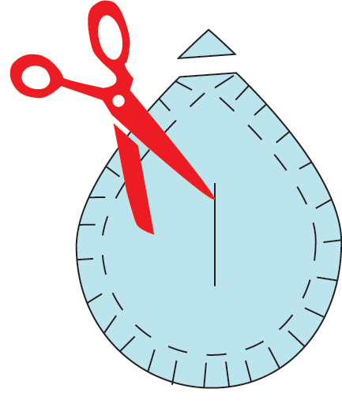
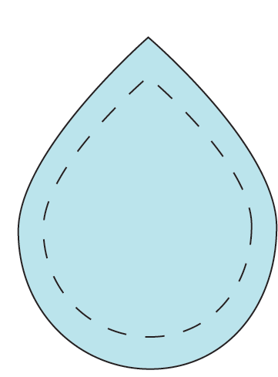

Stitch around entire shape Cut slit in one side for turning and stuffing

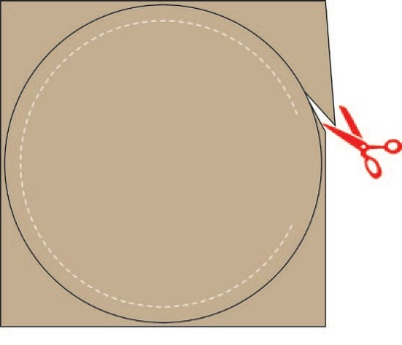
Stitch on drawn line, leaving
an opening for turning. Cut ¼'' seam allowance past the stitched line.

2. Stuff the nest with fiberfill, placing the stuffing a bit thicker near the outside edges and thinner in the middle. Turn the wrong side of the opening under ¼” and hand stitch closed.

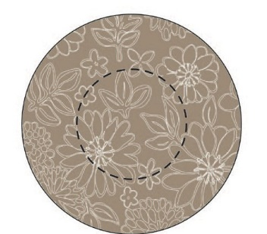
3. Using a compass or glass or jar lid, draw a 2-½” circle in the center of the nest. Hand sew a running stitch with loss on the drawn line.

Hand stitch an inner circle with embroidery floss to give the nest definition.

- Use floss to make French knot eyes or hand sew small beads, felt circles, or buttons for the eyes.

Tip: A birdie can be easily turned into an ornament. Simply omit the filling muslin bag to reduce weight and add a floss loop to the back for hanging!
COPYRIGHT
For personal use only. Reproduction of any part of this pattern in any way whatsoever without written permission is strictly prohibited. If this design is used in a quilt for display, please credit “Sharon Holland” for the design. All rights reserved. © 2015 Sharon Holland

Eye

Beak point
Tail point

Body
Cut (1) 1
& (1) 1R

Wing placement

Beak point

1’’ measuring guide for printing. Print at 100%

Beak point
Tail
Cut (2)

Tummy
Cut (1)

Back
Cut (1)

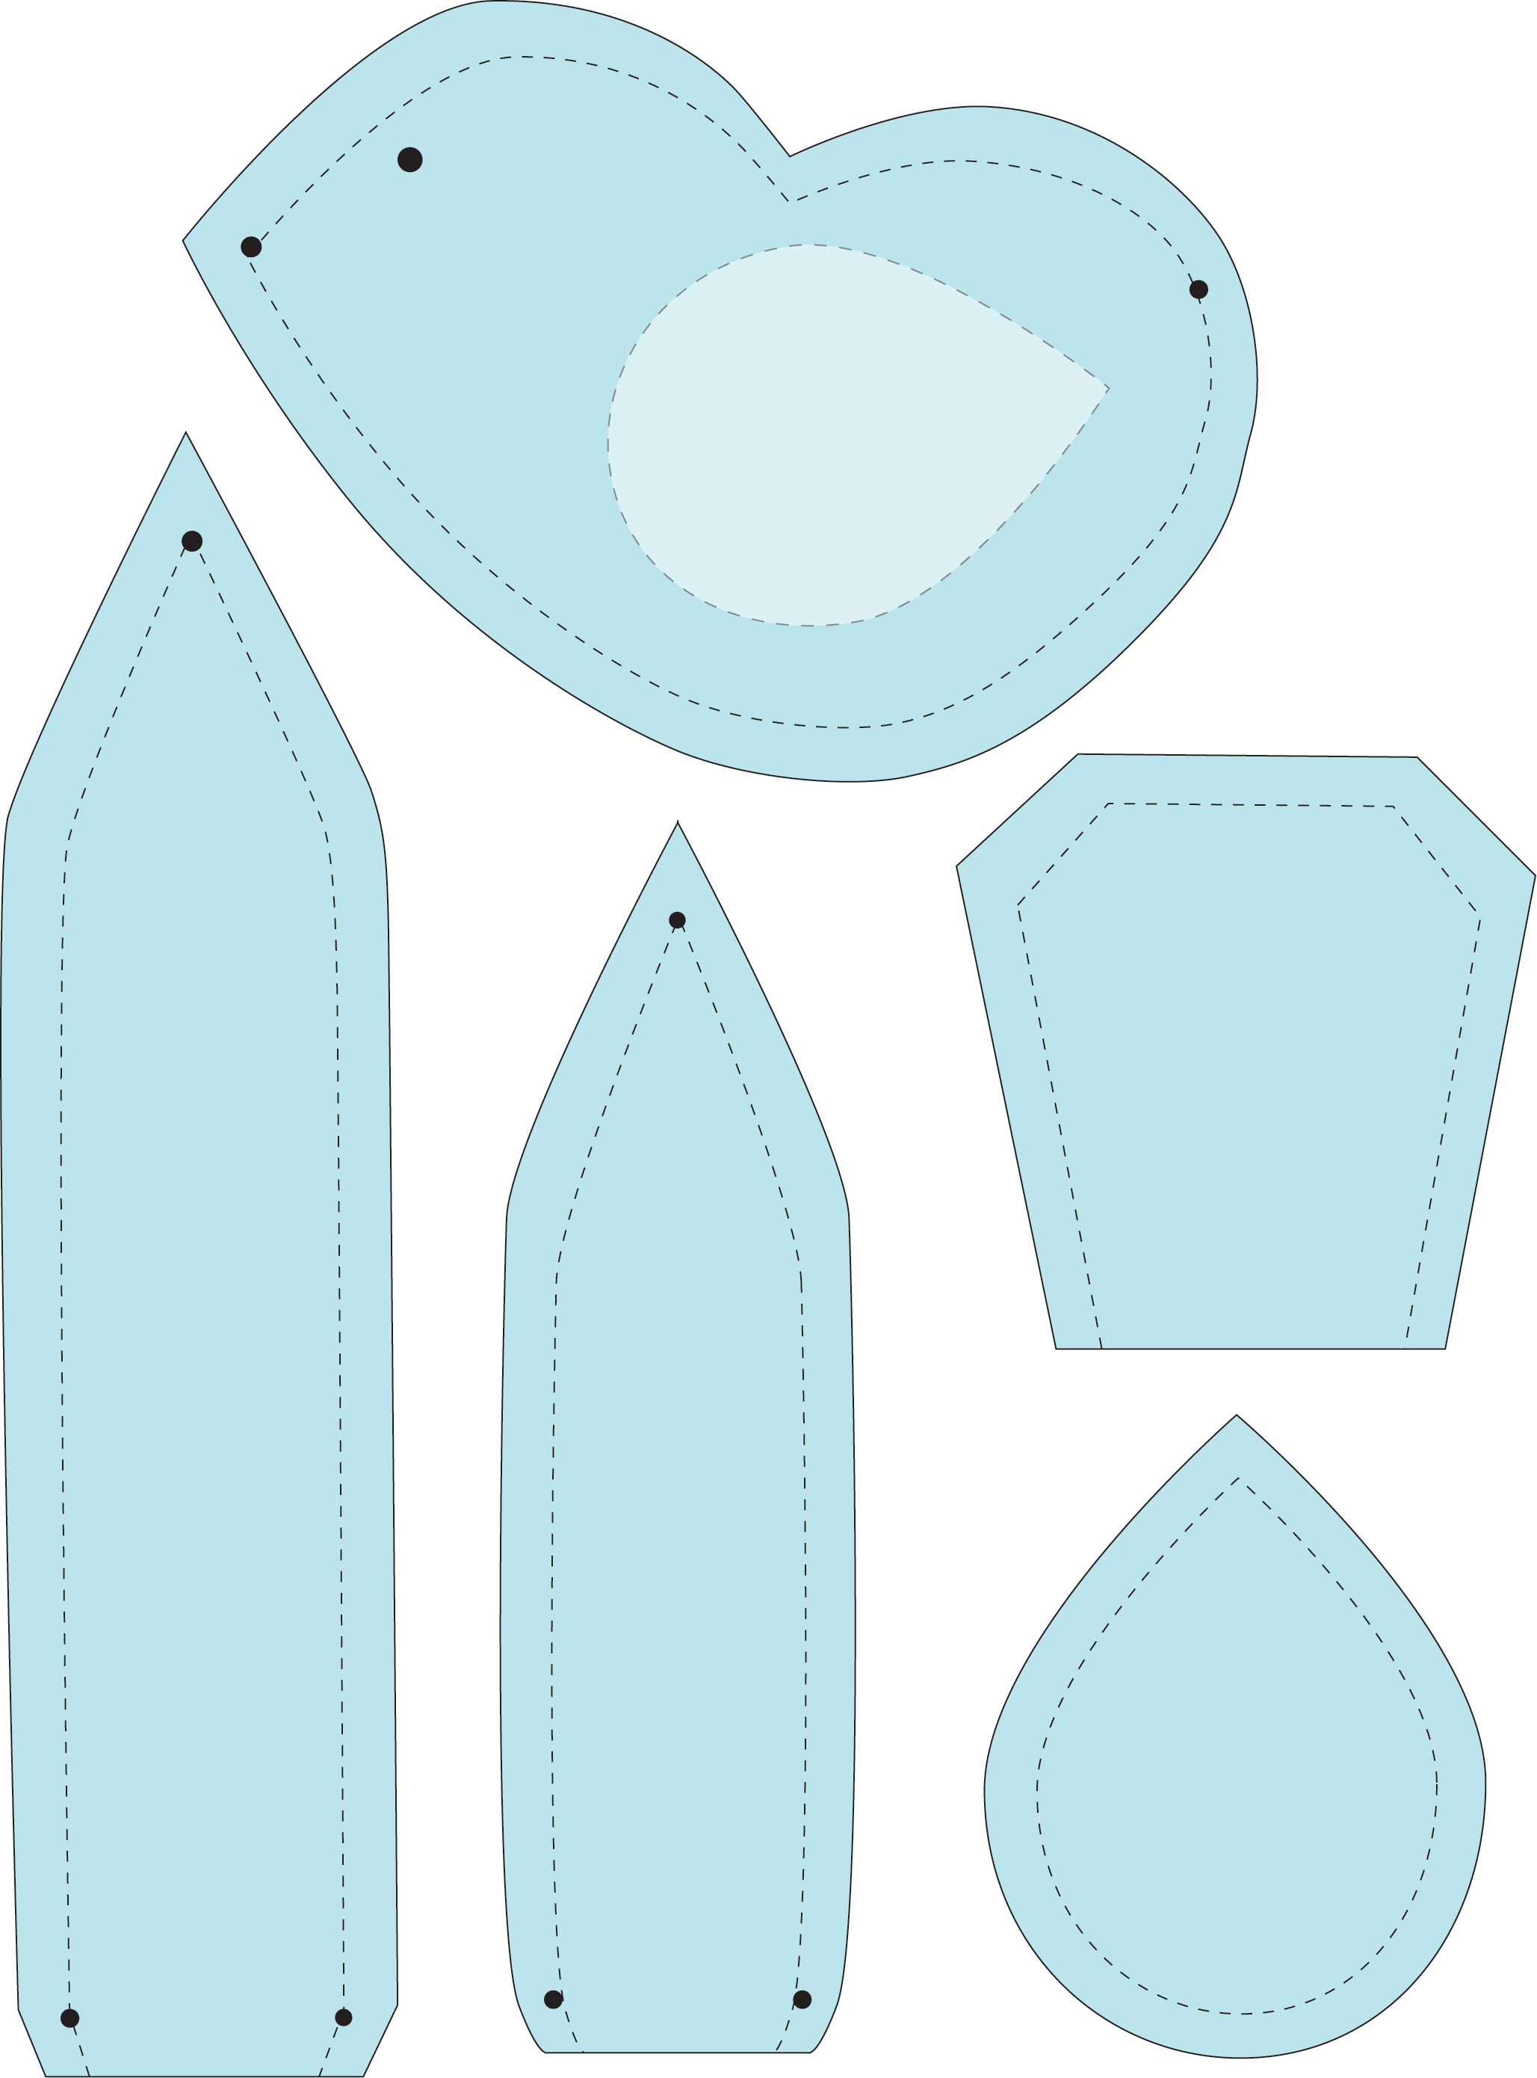

Tail points

Tail points
Wing
Cut (4)

