Macramé of the '70s: The Softest, Shaggiest, Most '70s Art Form Ever
By Rebeka Knott | June 15, 2018

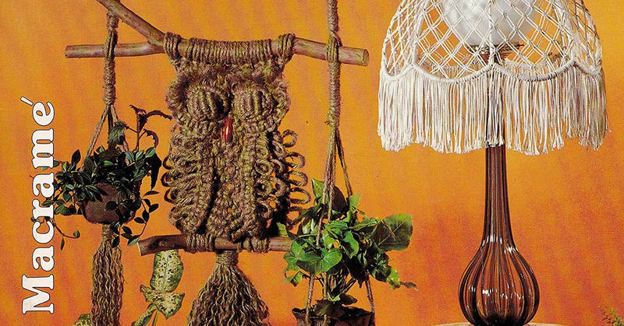
Detail of the cover of 'New Macramé,' a typical '70s macramé craft magazine. Source: Amazon.com
It was the crafty craze of the '70s -- macramé! A weaving and knotting technique that made soft, shaggy, volumetric things that could be hung or worn. Macramé was -- and is -- an extremely versatile art form, and in the far-out hippie and post-hippie culture, it was appropriate in any room. Macramé pets, macramé owls, macramé plant hangers, macramé dream catchers, macramé furniture -- if you could dream it up, there's a good chance you could make it. And people did, filling their houses, walls, and wardrobes with macramé.
Of all the '70s furnishings and knickknacks that look hopelessly dated today, macramé might be the champ. There's just nothing like a few macramé hangings to suggest that the person who lives here had a great time back in the Age of Aquarius. And so, while we smirk a bit at macramé today, it is like a hanging secret or symbol. Any Millennial or Gen-Xer can put on some Fleetwood Mac or turtle-wax the newly restored GTO in the driveway. But if you've got a wise old macramé owl keeping watch in your converted basement rec room, you were there, man. And part of you still is.
Part of you still is. Let's look at some macramé.

Knotty and Nice
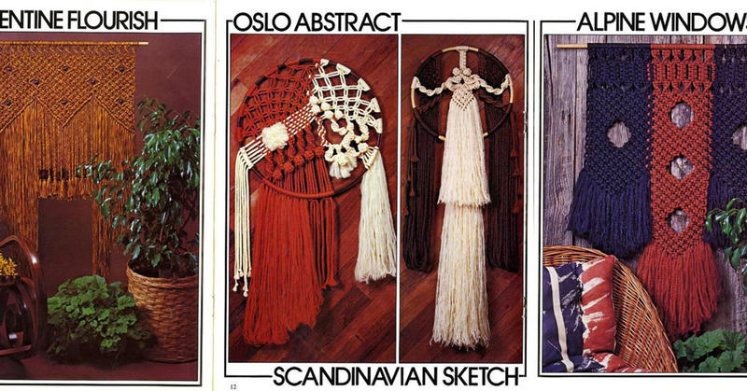
'Florentine Flourish,' 'Oslo Abstract,' Scandinavian Sketch,' and 'Alpine Windows' -- scans from 'Wall Decorating with Macramé' by Otti Miles. Source: vintagepatternwarehouse.com
Macramé is a craft of knotting using cotton, hemp and/or jute rope. The technique is described and defined as a succession of weaving and knotting used to make something. Years ago, it was associated with the groovy counterculture. Macramé can be created on any scale from small to large and usually involves an intricate and/or delicate pattern. This craft is really an art and true macramé is not done with machines but by hand.

The Noble Macramé Owl. This Was A Thing
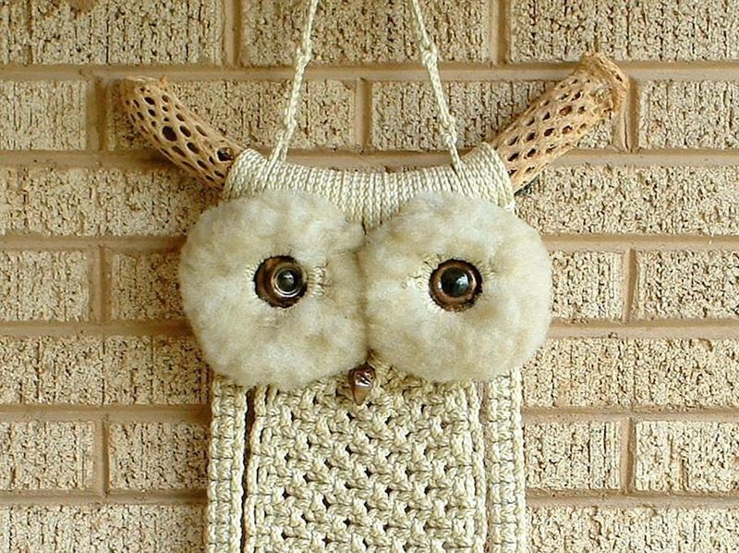
The art of macramé was used to create a variety of products. It became especially popular during the 19th century for American home décor. It sounds strange now, but many people proudly displayed various macramé items around the house. Everything from tablecloths, wall hangings and plant hangers could be seen in just about every house in the '70s.

More Macramé Owls Than People

We really do have to pause to ponder the macramé owl. Later generations might not know what to make of these artifacts. Why did ancient people of Britain build Stonehenge? Why did ancient Egyptians build the pyramids? And why did practitioners of macramé make so many gosh-darned owls? Why an owl and not an eagle, a camel, a trout? An owl looks like an easy project -- put two eyes on a macramé blob and tie a horizontal stick below it and presto, it's an owl sitting on a branch. Whatever the reason, a lot of macramé owls were born during the medium's heyday, and if you've still got a macramé decoration hanging in your house, there's a good chance it's an owl.
Contact / About Us / Privacy Policy / Terms Of Service / DMCA Notice
