Measure UP! Worksheet

Baking requires the most accurate measurements possible so the product turns out the same each time. Scales are most accurate, It is always best to use the fewest number of measuring steps or units possible for the most accuracy. EX: It
is more accurate to measure 185 ml ﬂour with 125 ml + 60 ml (I+K) than it is to use 60 ml + 60 ml + 60 ml + 5 ml (K+K+K+B). Also, it’s best to measure liquids with a liquid cup unless the recipe calls for less than 50 ml.

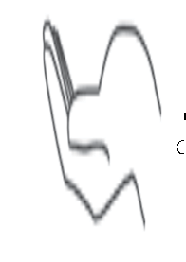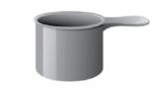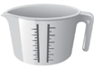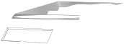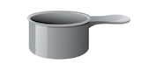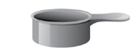A. 15ml E. electronic scale I. 125 ml
T
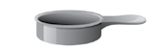
B .5 ml F. liquid measuring cup J. 80 ml C.2 ml G. hand K. 60 ml

G
1/2
t
1/4
t
t
D. 1 ml H. 250 ml
L. 25 ml

Directions:
For each ingredient listed, write in the blank the combination of letters you would use for the BEST way to measure that ingredient. In some cases, two answers may work. List all the best options. Use the Measurement Guide for equivalents and abbreviation help.

1. 250 ml sugar 13.
45 ml ﬂax meal 25.
80 ml brown sugar

2. 1 large egg 14.
45 ml baking powder 26.
185 ml water

3. 20 ml oil 15.
125 ml butter 27.
185 ml baking mix

4. 60 ml water 16.
375 ml grated cheese 28.
30 ml butter

5. 12 ml dry yeast 17.
96 g active dry yeast 29.
2 egg whites/56 g

6. 160 ml cornmeal 18.
3 medium apples (454 g) 30.
115 g pastry ﬂour

7. 30ml corn starch 19.
308 g spice mufﬁn mix 31.
80 ml oil

8. dash nutmeg 20.
4 ml ground cinnamon 32.
a pinch of salt

9.
60 ml corn syrup 21.
125 ml baking cocoa 33.
175 ml milk

10. 454 g powdered sugar 22.
225 g cheddar cheese 34.
250 ml applesauce

11. 1 medium zucchini 23.
387 ml can pumpkin 35.
1000 ml rolled oats

B

