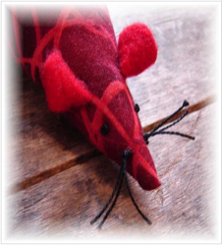
Mouse Pincushion

15 cm Square of fabric | felt scraps
yarn | stuffing
embroidery thread | steel wool
2 small buttons for eyes (opt.)
Materials:

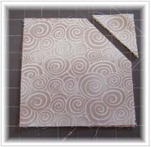
Instructions:
- Take the 15 cm square of fabric measure 7 cm from the corner in each direction. Mark these points and draw a straight line, creating the diagonal; cut off the corner as shown.

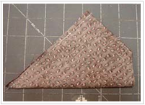
- Fold the square in half to form triangle. Sew the long straight edge from corner to corner using the whip stitch, slip stitch or back stitch. This the edge across from the folded edge. See picture.

- Turn right side out and poke out the tip with a sharp object (like a pencil, pen, etc.)

- Fold the top edge under and use a running or basting stitch to gather the material. Do not knot or tie off the thread.
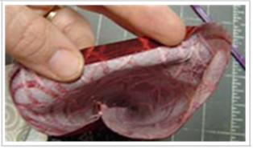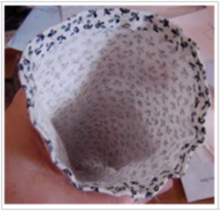

- Stuff firmly with first batting wrapped around steel wool and draw the fabric up tight and sew the opening closed.
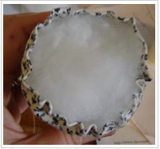
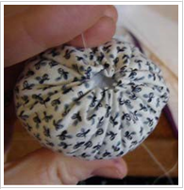

- Cut 3 equal lengths of embroidery thread and braid them together to make the tail. Use a large eyed needle insert into the gathered end of the mouse.
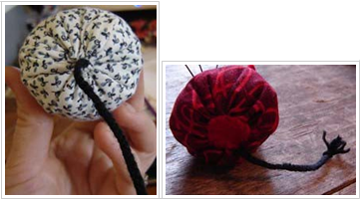

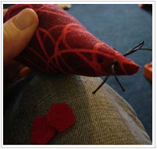
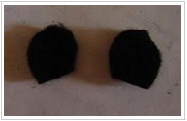
- Cut two ears from scrap pieces of felt and stitch them to either side of the head. Add eyes and whiskers.

