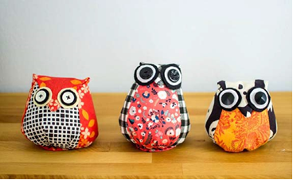
Owl Pincushion

2 different scrap fabric pieces | felt pieces for the eyes
2 buttons | needle and thread for sewing
stuffing and steel wool | felt for bottom cover
Materials
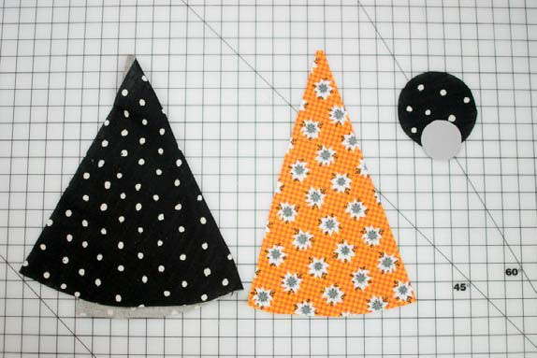
Instructions
- Fold main (body) fabric in half and cut 1 body piece on the fold.
- Cut one tummy piece from the coordinating fabric – not on the fold.
- Cut a 2.5 cm circle of felt for the bottom of the owl.

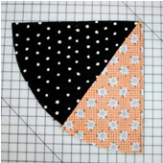
- Place the tummy and body pieces right sides together. Use a whip stitch, back stitch, or slip stitch and sew two long sides together. Repeat for the other side of the tummy and body pieces.

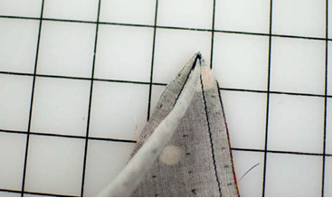
- Trim the top peak close to the stitching to remove the bulk.
- Turn right side out and use a pointy object to push out the corner.

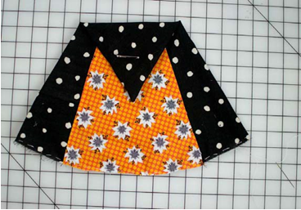
- Fold the tip down about $1/3$ of the way down for the owl’s beak. Sew along the tip of the beak – using whip stitch – to tack it to the tummy to keep it folded.

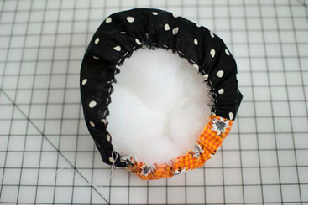
- Use a running or basting stitch to gather the material. Do not knot or tie off the thread.
- Stuff with fiber fill wrapped around steel wool. Pull the thread closed and sew the opening closed.

- Sew the felt circle to the bottom of the the gathered area using a whip stitich.
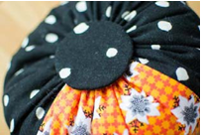
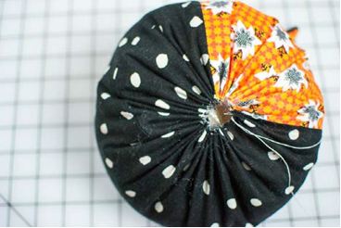

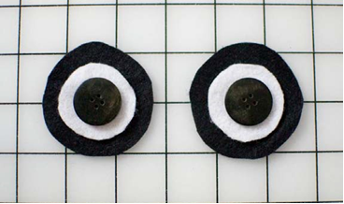
- Make the eyes: choose two buttons that you want to use. Cut circles of fabric ½ to 1cm larger than the buttons. Cut circles of a second colour of felt ½ to 1 cm larger than the first felt circle. Sew the buttons through both layers of felt.

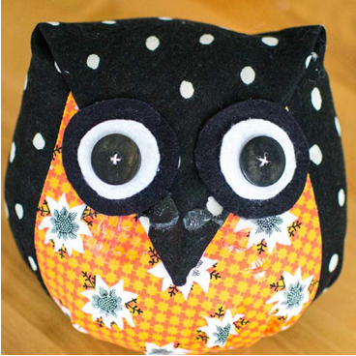
- Sew the eyes onto the face using a whip or blanket stitch.

