Parts of the Sewing Machine –

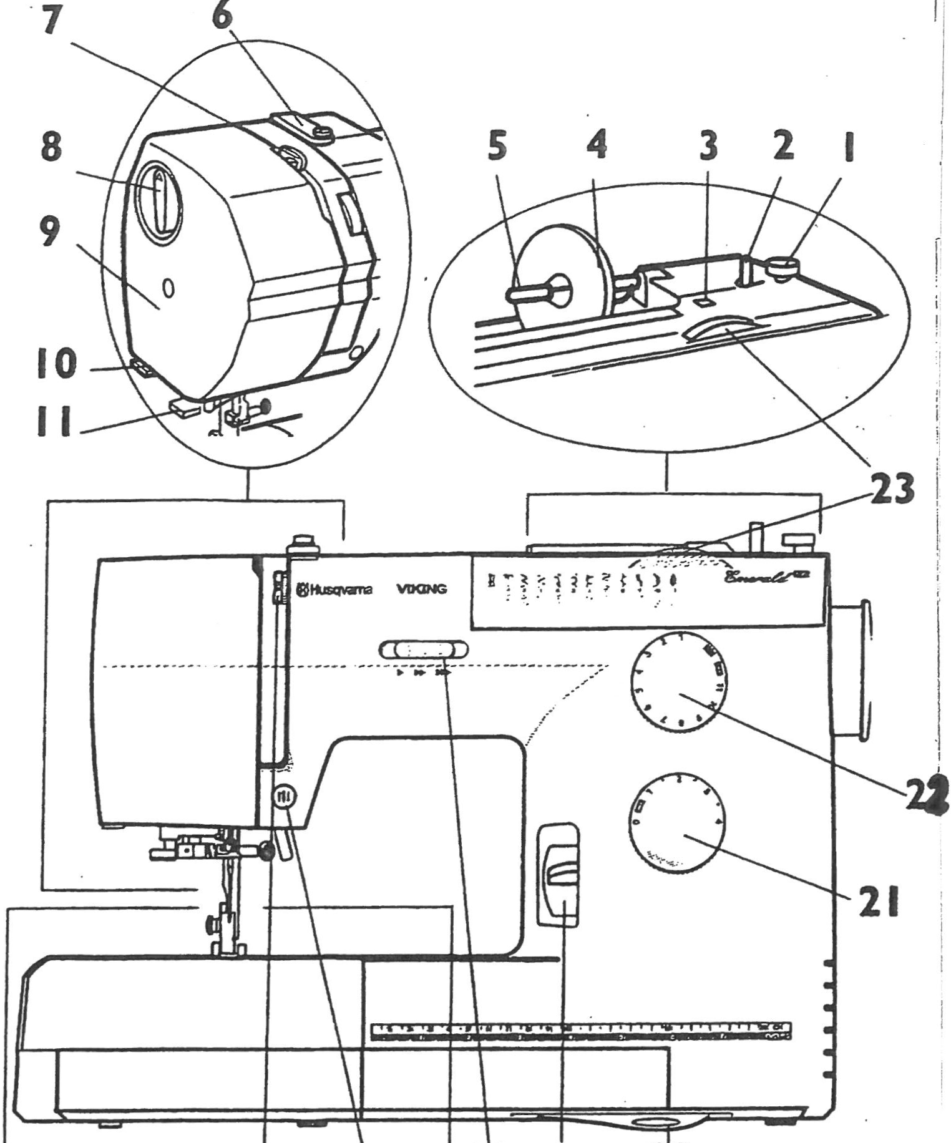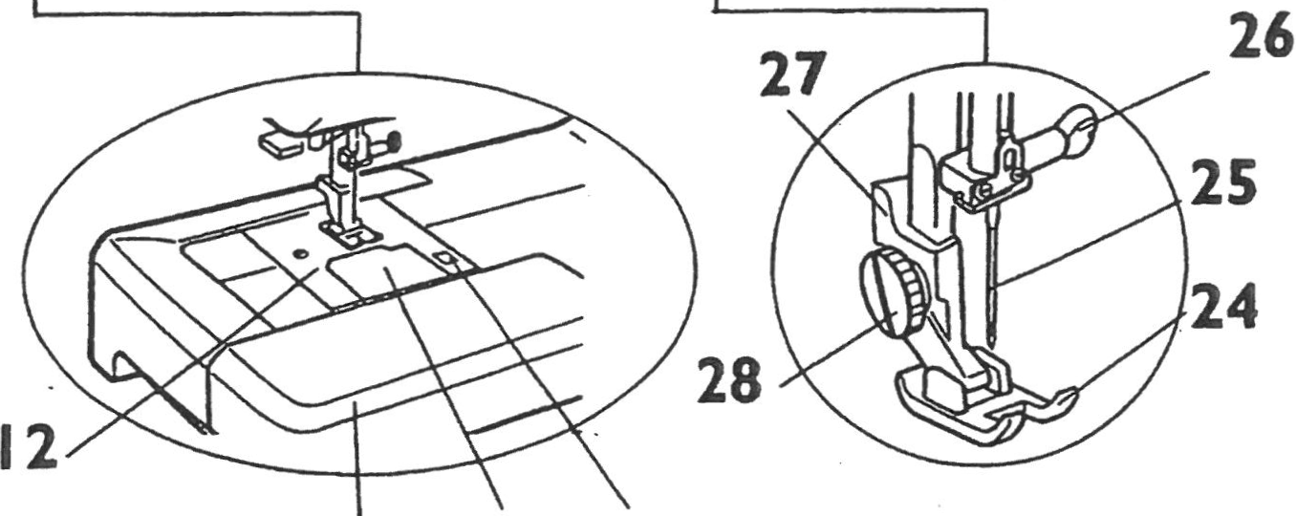

Husqvarna Emerald 118

**16 17 18 19 20**

|  |
| --- |
| 4. Spool Holder |
| 5. Spool pin |
| 7. Thread take up lever |
| 10. Thread cutter |
| 11. Needle Threader |
| 14. Bobbin case cover |
| 15. Bobbin cover release |
| 17. Needle up/down button |
| 18. Speed control slider |
| 19. Reverse Button |
| 21. Stitch Length dial |
| 22. Stitch Selection dial |
| 23. Stitch width dial |
| 24. Presser foot |
| 25. Needle |
| 29. Carrying Handle |
| 30. Hand wheel |
| 31. Power switch |
| 32. Foot pedal socket |
| 33. Power cord socket |
| 37. Presser foot lifter |

**13 14 15**

