Quick Breads
Quick breads usually use baking powder as a leavening agent. They are put in the oven to bake as soon as they are mixed.
Breads made from whole-grain or enriched flour are good sources of vegetable protein, B vitamins, and mineral.
Breads do not get stale as quickly if they are kept in a breadbox at room temperature instead of in the refrigerator. However, in hot, humid weather, refrigerate bread to help keep mold from growing. Bread may be frozen by sealing in a plastic bag and placing in the freezer.
Breads are made from batters and doughs. There are two types of batters.
Pour batters are thin and can be poured into a baking pan.
Ex. Pancakes or waffles
Drop batters are thick enough to be dropped from a spoon and hold their shape.
Ex. Muffins or dumplings
Doughs are so thick they can be shaped by hand.
Ex. Biscuits or scones
Quick bread includes pancakes, waffles, muffins, biscuits, loaf breads, and coffee cakes. Nuts and fruits can be added for flavor and nutrition.
Two basic methods can be used to make quick breads – either the muffin or biscuit method.

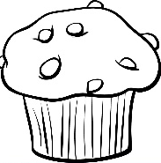
Muffin Method

In the muffin method of mixing, the way you mix the batter is important. The batter must be mixed only a short time – just long enough to moisten the dry ingredients evenly with the liquid. Too much mixing makes the gluten too strong.
The product with have an irregular shape, or peaks, a tough, crust, and tunnels.
To make quick breads with the muffin method:
- Line the muffin tin cups with paper liners.
- Preheat the oven to the temperature given in the recipe.
- Sift and measure the dry ingredients together into a large mixing bowl.
- Beat the eggs in another bowl. Add the milk and oil or melted margarine and mix.
- Make a well in the dry ingredients – push all the dry ingredients to the edge of the bowl.
- Pour the liquid all at once into the flour mixture.
- Stir only until the flour is moistened. Do not stir the mixture any more than need to moisten the flour. The batter will look lumpy.
- Gently spoon the batter into the prepared pan.
- Bake until done
Test for doneness:
- A toothpick inserted in the center will come out clean.
- Check the colour. The crust should be golden brown.
- Look where the top meets the sides of the pan. The product will have pulled away slightly from the sides.
Muffins and quick breads should:
- Have a uniform shape and well-round top with no peak.
- Be uniform in size and fairly heavy for their size
- Have a golden-brown, tender crust that is slightly rough and shiny
- Be free from tunnels on the inside
- Have a tender, moist texture
- Have a pleasing, well-blended flavour

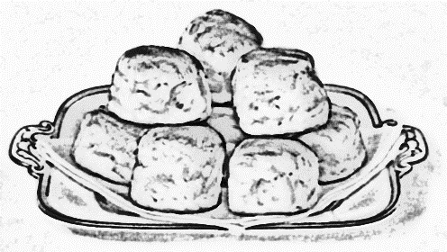
Biscuit Method

The ingredients used to make biscuits are: flour, salt, baking powder, fat, and milk.
Biscuits can be made either from a drop batter or a dough. More liquid is added to make a drop patter. If a drop batter is used, the biscuits are dropped onto a cookie sheet from a spoon. When a dough is used, the dough is rolled out on a floured surface, Then the biscuits re cut out with a cookie cutter.
To make rolled biscuits:
- Preheat the oven to the temperature specified in the recipe.
- Biscuits are baked on an ungreased baking sheet unless the recipe give other directions.
- Sift the dry ingredients together in a mixing bowl.
- Add the fat to the flour and cut into the flour mixture using a pastry blender.
- This make very thin layers of fat coated with flour. The thin layers of fat five a flaky texture when the biscuits are bakes, Cut the fat into the flour unlit the mixture looks like coarse crumbs.
- Add the milk gradually tossing with a fork to make a soft dough. The dough should not stick to the sides of the bowl.
- Turn the dough out onto a lightly floured surface and knead 8-10 times.
To knead dough:
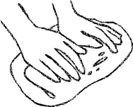
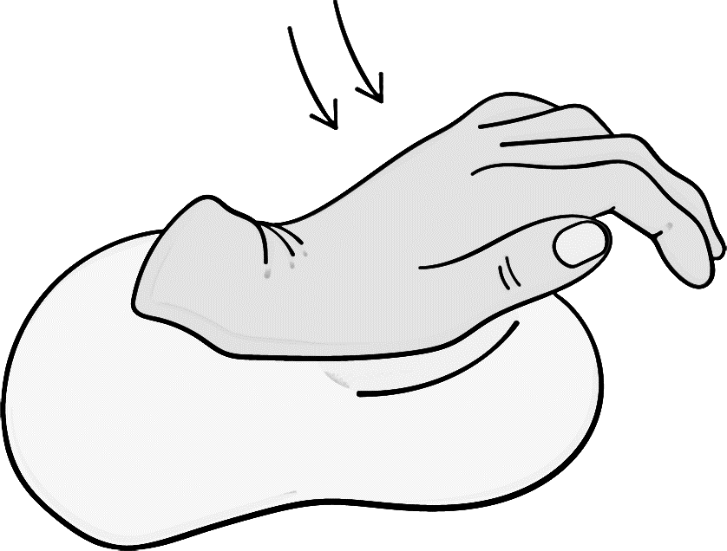

gently fold the dough push down on dough with give the dough a
over in half towards you the heels of both hands quarter turn. Repeat.

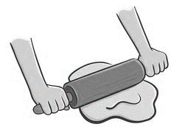
Use only enough flour to ensure the dough does not stick to the counter. Roll out into a circle about 1.3 cm thick. Roll from the center out in gently, light strokes.

Cut out biscuits with a cutter. Push straight down – do not twist, the biscuits will be uneven.
Place on a baking sheet, leaving about 2.5 cm between them.
Push left over dough together – do not knead – and cut out more biscuits. The last one will be the left over dough squished together.
Bake in preheated oven for given time.
Test for doneness:
- Biscuits will be browned on top. The sides will be a lighter cream colour.
- The sides should be straight. The biscuits should be double in size.
Biscuits Should:
- Be uniform in size and shape with level tops and straight sides.
- Have uniform golden brown tops and bottoms with lighter sides.
- Have a tender crust.
- Be moist and tender on the inside.
- Have a light, flaky texture and peel off in thin sheets.
- Have a well-blended, pleasing flavour.

