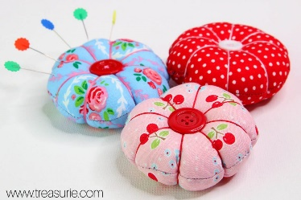
Round Pincushion

Materials:
2 – 12cm square pieces of fabric | matching thread for sewing
contrasting or matching embroidery floss | Stuffing  10 cm circular object
1 - button

Instructions:
- Using a bowl, plate, or something round, trace out two 10cm circles on your fabric.
- Place the fabric circles right sides together. Sew the circles together using a backstitch about 0.5cm from the edge, leaving a 3cm gap.

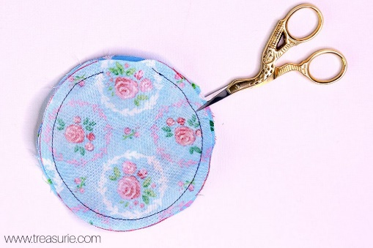
- Clip the edges all around where you have stitched. This means putting small snips around the edge without cutting the stitches you made. Alternatively, you can clip the edge with pinking shears.

- Turn the pincushion outside right through the opening you left. Press the seams.

- Stuff the pincushion with filling until till very full and firm.

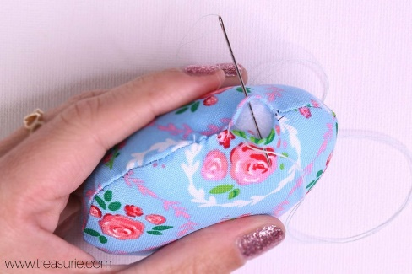
- Close the gap with a ladder stitch; being sure to fold down the seam allowance before stitching.

- Cut a piece of embroidery thread that is about as long as your arm. Knot the end and locate the approximate center of your pincushion. Pass the needle through the top center and all the way through to the bottom center, pulling the thread tight.

- Bring the needle up and around to the top again and pass through the same point again. Repeat until you have 8 segments – pulling the thread tight enough to give it a slightly puffy look.

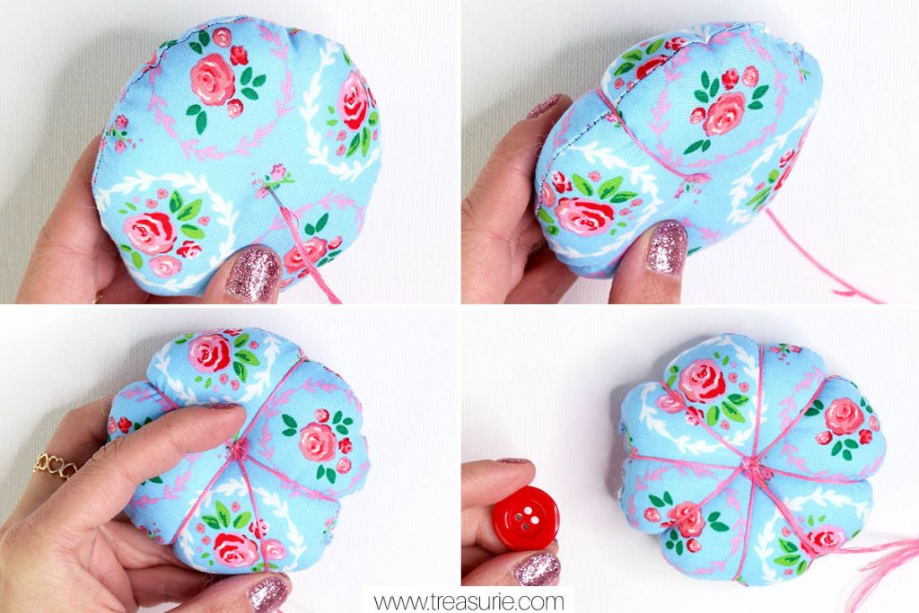
- Knot off the floss and cut.

- Choose a button to sew on the top of your pincushion over the knot on the top. Use sewing thread and sewing only through the top layer.

