Sewing Routines and Safety

Classroom Routines (use the words from the box below)
Name: Block:

1. Always arrive on and quickly take out your box of supplies.
2. Place all bags, jackets and binders beside the ____________ or under the ______________ when you enter the room.
3. If you , you have the option of coming in after school or at lunch every day.
4. Pay attention and do not during instruction time.
5. Follow the instructions and pattern directions.
6. During a lesson, you must , look & .
7. Start clean up minutes before the end of class.
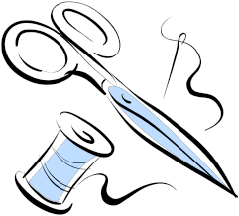8. Students are not dismissed until:
• and supplies are put away
• has been placed underneath the presser foot
• have been checked by the teacher
• given teacher to leave the class

fall behind listen interrupt | teacher’s scrap fabric bookshelf | time  sewing machines equipment
stop  white board | five | permission

Safety (select the correct words from the box below)
1. Never run a sewing machine at high speeds, even when winding a .
2. Never in the Home Ec room – even if there is a fire.
3. Report all and bent sewing machine needles to the teacher.
4. When determining if an iron is hot, run the iron along the and then feel the temperature of the board.
5. Always store in a pin cushion – do not leave on sewing table surface.
6. Always pins from fabric as you sew to avoid sewing over them.
7. Never look or while you are sewing.
8. Do not run machine at high speeds as this may cause the needle to .
9. Always the sewing machines and irons by pulling on the plug as opposed to the cord.
10. Always hold the fabric with your well away from the path of the sewing machine needle.
11. Always ensure the thread lever is up before removing fabric from the machine. This will prevent bending or breaking the needle. In addition, this will prevent the thread from knotting in the machine or fabric at a later date.

pins | up | break
bobbin  take-up remove | broken  run fingers | unplug  away  ironing board

Safety While
Sewing

Name: Block:

DIRECTIONS: List all the safety hazards you can see in this picture.

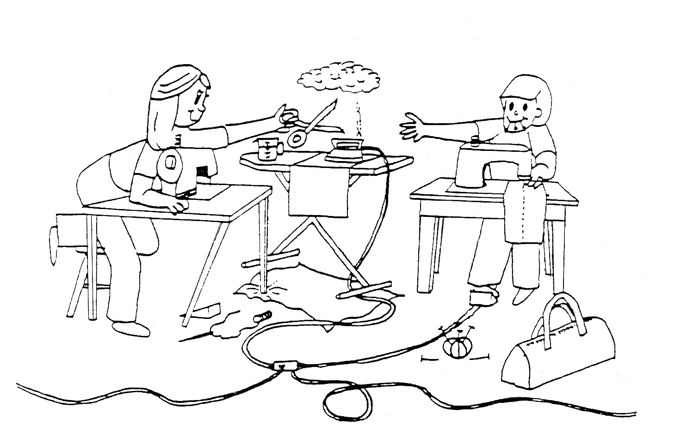1.

2.

3.

4.

5.

6.

7.

8.

9.

10.

11.

12.

13.

14.

15.

16.

17.

18.

19.

20.

