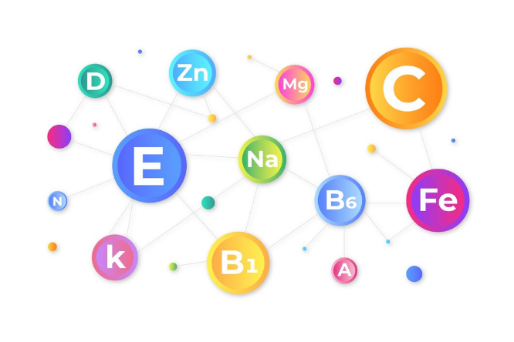
The Importance of Micronutrients

Vitamin and Mineral Research Assignment

The micronutrients are so “micro” because we need them in smaller quantities than the macronutrients – fat, protein, and carbohydrates. Humans do not make these nutrients so they must be obtained from the food that makes up our diet. The vitamins and minerals are required in various amounts, depending upon its function in the body. You will be researching the importance of the various vitamins and the macro minerals. There are several minerals that the body requires in very small quantities, but you are going to focus only on the most commonly known ones.
You will be creating an infographic (see example to the left) to summarize the information necessary for this assignment. There are many different templates to choose from Canava or Adobe Express – the links for both websites can be found on the website. You will need to research this topic and tell me in your own words what you learned.

Required Elements:
- Micronutrient definition.
- List of fat vs. water soluble vitamin.
- List of the macro minerals.
- Main functions of the micronutrients in the body/ why are they important?
- What happens if there are deficiencies?
- Main food sources of the vitamins
- Main food sources of the minerals.

Bonus:
- Describe antioxidants and the role they play in the body.
- When are vitamin & mineral supplements necessary?

