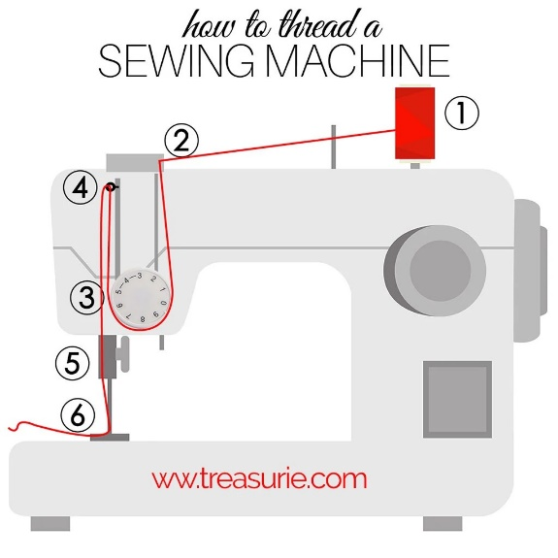

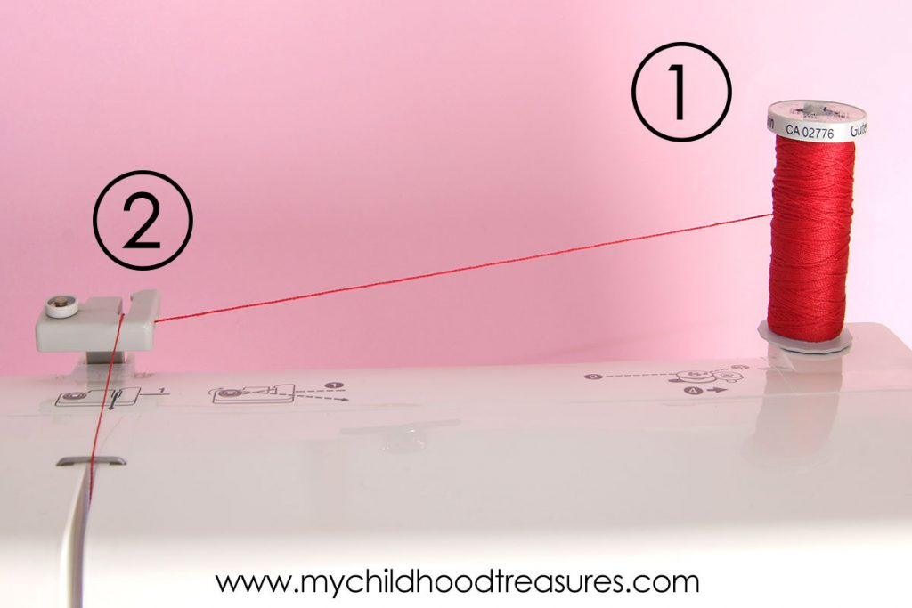
Step 1: Top Spool
Put the cotton on the spool at the top of the machine. Depending on your make of machine, this may be an upright peg or one lying down. Your machine may have a plastic disk to put on top of the spool to hold it in place and to stop it flying off the top once you start sewing.

Step 2: Thread Guide
Pull the thread through the thread guide on the top. This Brother machine has a rather large guide. Often the guide will be a small button-like knob.

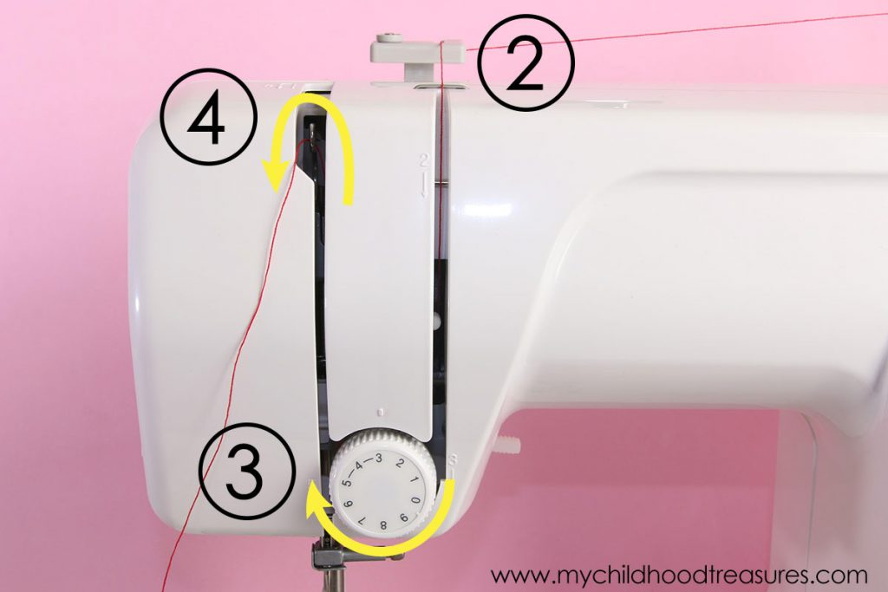
Step 3: Around the Tension Knob
Pull the thread down towards you and loop it around the tension discs below.

Step 4: Second Thread Guide
Then pull the thread back up again into the second thread guide. This will have a lever with an eyelet, generally called the take-up lever. This creates a U shape with the thread.

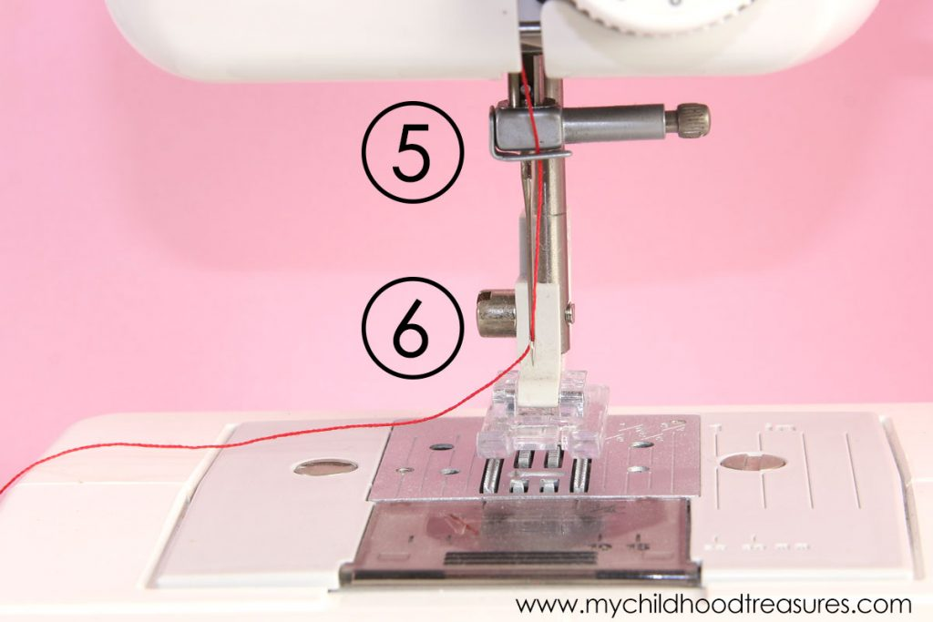
Step 5: Above Needle Hook
Bring the thread down to the needle following any hooks to hold thread.

Step 6: Thread the Needle
Then thread the needle from the front to the back. If you are having trouble threading the needle, then see the tips further down this article.

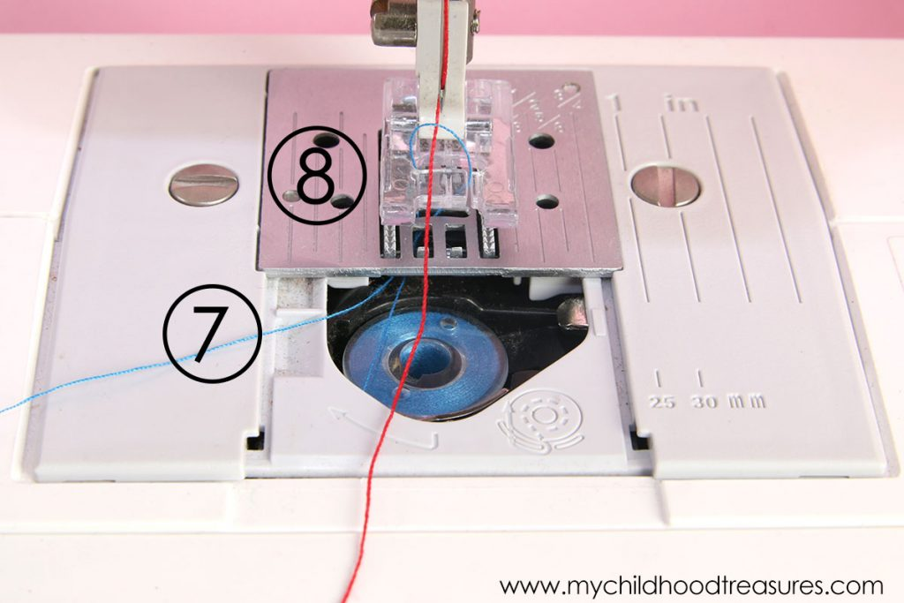
Step 7: Insert Bobbin
Load your wound bobbin as per your bobbin type and manual instructions. Your machine may have the bobbin inserted from the top or from the front. Some makes of machine have a removable case that the bobbin inserts into and others drop straight down into a fixed position.
Turn the flywheel (big wheel on the right side of the machine) towards you so the needle hooks up the top thread with the bottom thread.
Bring the thread from the bobbin to the top of the machine plate where the needle moves in and out.

Step 8: Join the Bobbin and Top Thread
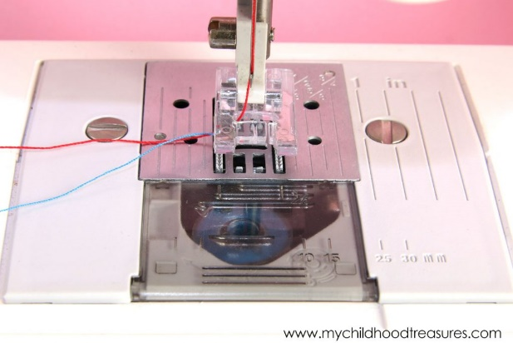
Find the loop of bobbin thread that is being caught and pull it to the top. You may need tweezers or a pin to help grab it.

Step 9: Pull the Threads to the Back
Gently pull both threads to the back. They should run freely as you pull them.

Step 10: Test on a Scrap
Take a scrap of fabric and check your stitches and tension. Hold the threads gently at the back as you start sewing so that you don’t tangle the top and bottom threads. Remember to lower the foot to steady the fabric and connect with the feeder mechanism.
Ready, steady, good to go on your perfectly threaded sewing machine.

