WEIGHING IN: THE IMPORTANCE OF MEASURING INGREDIENTS IN BAKING
JANICE LAWANDI

As part of our ongoing Kitchen Basics series, we weigh in on the hows and whys of weighing and measuring your ingredients in baking, where it's all about precision!
There's one big difference between cooking and baking: precision.
Baking is a science and it requires all the precision you would expect when doing a chemical experiment. Your ingredient measurements have to be precise to get the chemical reactions you need and to score that perfect, consistent result every time.

SO YOU WANT TO BE A BAKER...
It’s as easy as dusting off your most valuable kitchen tool and no, it's not your fancy stand mixer. Your most valuable kitchen accessory when baking is... the kitchen scale! Place a bowl on it and weigh your ingredients and you're on your way.
I've had a lot of people come up to me, exclaiming that they simply cannot bake!
From these conversations, I've realized that it's not that they can't bake, it's that they don't really like sticking to the recipes they're baking from, let alone measure out their ingredients! (does this sound like it could be you?)
They fall into the bad habits of guesstimating amounts and eyeballing. Eyeballing may work when you're making soup, but if you're making a batch of cookies, precision really is the key to success and a consistent result, from one batch to another. And that's where your kitchen scale pays a very important role!
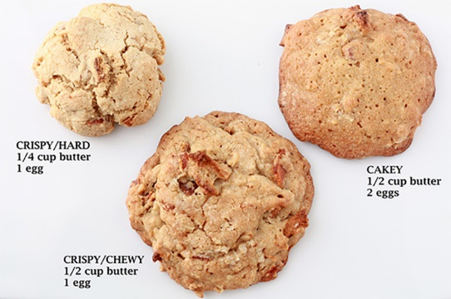
Take a look at the photo for Bacon whiskey apple cookies. All three cookies use the same ingredients but look how changing the amount of butter and eggs changed the shape and structure of the cookie!
Just 58 grams more of butter and/or an extra egg make all the difference. OK, fine, all these cookies contained bacon so they were all very tasty and scarfed in seconds, but still.

WHY IS MEASURING INGREDIENTS ACCURATELY SO IMPORTANT?
Baking IS a science. It relies on chemical reactions happening between your ingredients. Unfortunately, this means that you can't simply mix up a dollop of this, a pinch of that, a handful of flour and a few eggs, and expect to get the perfect chewy chocolate chip cookie!
Baking doesn't work like that (unless you have years and years of experience making your favorite cake recipe). For example, if you add too much butter or not enough flour, your cookies will spread. If you add too much baking powder, your cakes will taste funny, and will rise rapidly and then sink in the middle. Remember chemistry class when you were in school? You had all kinds of tools to make sure you had precise measurements for your experiments. Things might not have gone so well for you if you got your sulphuric acid measurements incorrect!
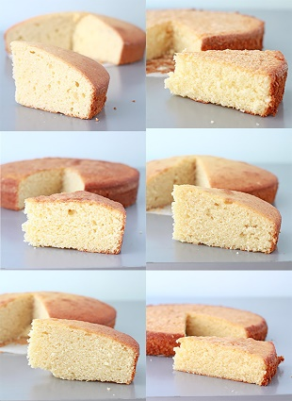
In the photo, all the cakes contain the same basic ingredients, yet they are clearly not the same. The main difference between them lies in the amounts and ratios of ingredients used! (Yellow butter cake recipe)
All these cakes contain the same basic ingredients, yet they are clearly not the same. The main difference between them lies in the amounts and ratios of ingredients used.

DRY MEASURING CUPS VS LIQUID MEASURING CUPS: THERE IS A DIFFERENCE.
Is there a difference between dry measuring cups and liquid measuring cups? Absolutely! They're different tools for different jobs.
Can you get away with using just one type of measuring cup set? In a pinch - for certain items like a standard chocolate chip cookie you definitely can and still have a great result. For more finicky baked goods measuring properly can be very important and the results can be very unforgiving if you screw up!

DRY MEASURING CUPS
Dry measuring cups are made to be filled to the rim with a dry ingredient (like flour), and then leveled. Sure, you could measure a cup of milk in a dry measuring cup, but filling it to the rim and transferring the liquid to your mixing bowl is awkward to say the least, and you’ll probably spill a little along the way. This is when liquid measuring cups come in handy.

LIQUID MEASURING CUPS
Liquid measuring cups are usually made with a pouring spout and graduated (with volume marks) for easy and clear measuring of liquids. The volume marks on liquid measuring cups always fall well below the pouring spout, making it easier to transfer liquids from cup to bowl. It also means that measuring a dry ingredient, like flour, isn’t so
So, use dry measuring cups for dry ingredients (flour, sugar, etc.), and use liquid measuring cups for liquid ingredients (milk, water, oil).

BETTER YET, MEASURE YOUR BAKING INGREDIENTS ON A SCALE
The fact is that how you fill your dry measuring cup with sugar or flour will affect how much of that ingredient you are adding into your mixing bowl, and therefore how your baked goods turn out.
Ideally, you spoon flour and starch ingredients into the measuring cup before leveling it off.
On the other hand, with brown sugar, you should pack it into the cup measurer like you are getting ready to build a sand castle. Some people might not know to pack the brown sugar into the measuring cup!
Maybe I prefer to simply scoop and level flour, while you fluff up the flour before scooping and leveling.
In all cases, the way you fill your measuring cup is a key step that makes your cookies different from mine, even if we're using the same recipe!
The only way to avoid discrepancies is to weigh your ingredients. It may seem like an extra step or a pain at first, but soon you will come to realize that you end up dirtying fewer dishes, making less of a mess and, more importantly, your cookie and cake recipes will yield better, more consistent results. I pretty much weigh everything on my scale. I even use my scale to evenly divide cake batter among my cake pans when I’m baking layer cakes.

YOU HAVE A KITCHEN SCALE BUT DON'T KNOW HOW TO USE IT
You are not alone! And, if it makes you feel any better, I have seen university-trained chemists flummoxed by a scale. I kid you not! In fact, many universities now offer science students extra lab sessions on how to measure using a scale or a graduated cylinder (which is basically the same idea as a liquid measuring cup).

HOW TO USE YOUR KITCHEN SCALE
If you have a digital scale, start by placing a bowl on the platform and “tare” or “zero” it to account for the weight of the bowl. Then measure your ingredients into that bowl.
If you're using a mechanical (dial) scale, place the bowl on the scale and then make sure that the hand lies at zero before you begin weighing into the bowl (there should be a dial at the back of the scale that allows you to adjust the position of the hand).

FOR THE LOVE OF CAKE, IF YOUR SCALE HAS A BUTTON FOR MILLILITERS, DO NOT USE IT!
Here’s where I unleash my inner chemist on you. The milliliter button on your scale is making the assumption that the liquids you are weighing all have the same density, specifically a density of 1 gram per 1 milliliter.
Basically, your scale is assuming that all liquids have the same density as water.
Unfortunately, this just is not true. Some liquids, like oils, have a lower density than water, and some have a higher density than water (like corn syrup). So please, for the love of cake and all things sweet and delicious, ignore the milliliter button on your scale.

KEY TAKE-AWAY WHEN IT COMES TO MEASURING INGREDIENTS
Sure, baking may require a little extra care in the measuring department, but it is well worth it! Practice makes perfect and think of all the yummy cakes and cookies that will come from your endeavours!

